E-Portfolio Week 2 Task: Provide evidence of creating a pull request

Repository: <https://github.com/ajheslop/ePortfolio>

# Outline:

The overall idea of this repository was to create a week by week accountable repository, where files in which I was working on can be stored. Thus, I created Week One & Week Two.

# Week One:

Week one will contain everything I used or worked on in that week, this is a good idea when referring to this week.

# Week Two:

Week two will contain everything I used or worked on in that week, this is a good idea when referring to this week.

The following screenshots provide evidence of pull requests for both Week_One & Week_Two, following a screenshot with a completed merge.

# Evidence of a pull request

As there have been changes made GitHUB has now updated to let the user know there are changes to compared and pull request made.

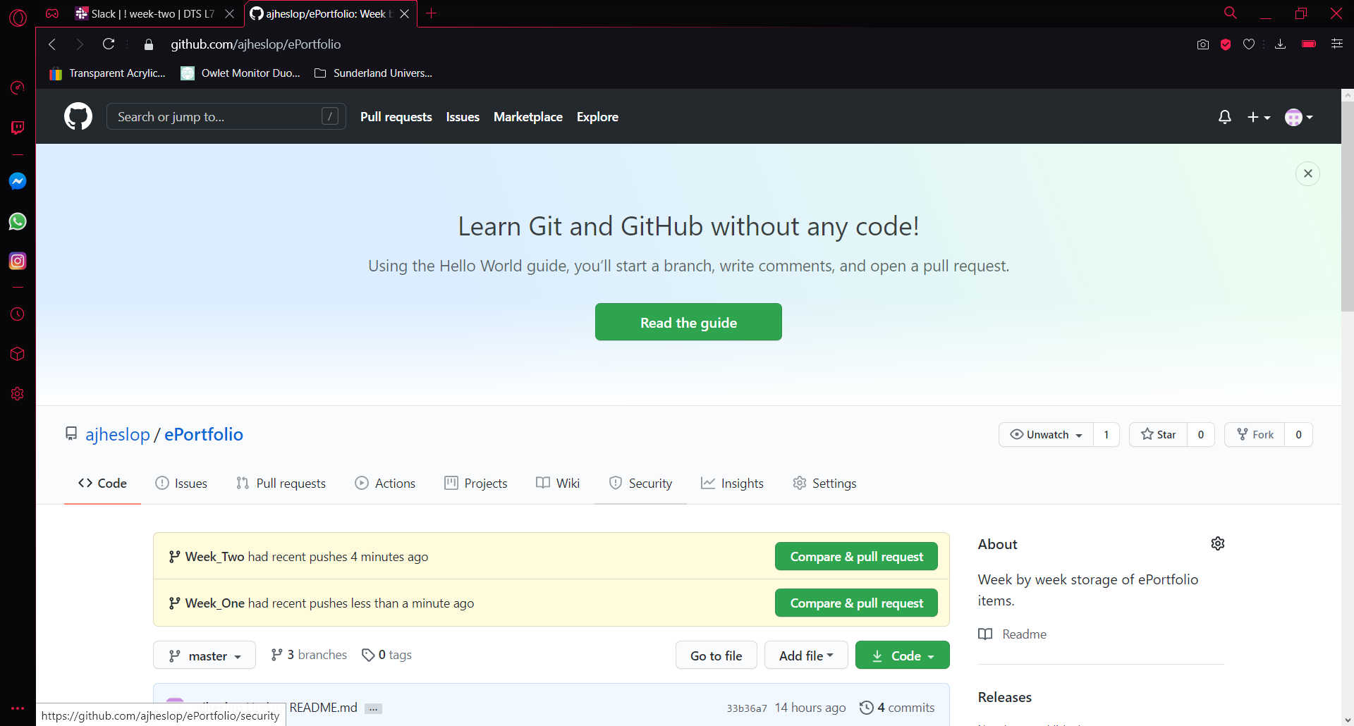

# Evidence of three branches in total

Evidence that there are three branches; master (default), Week_One & Week_Two are created.

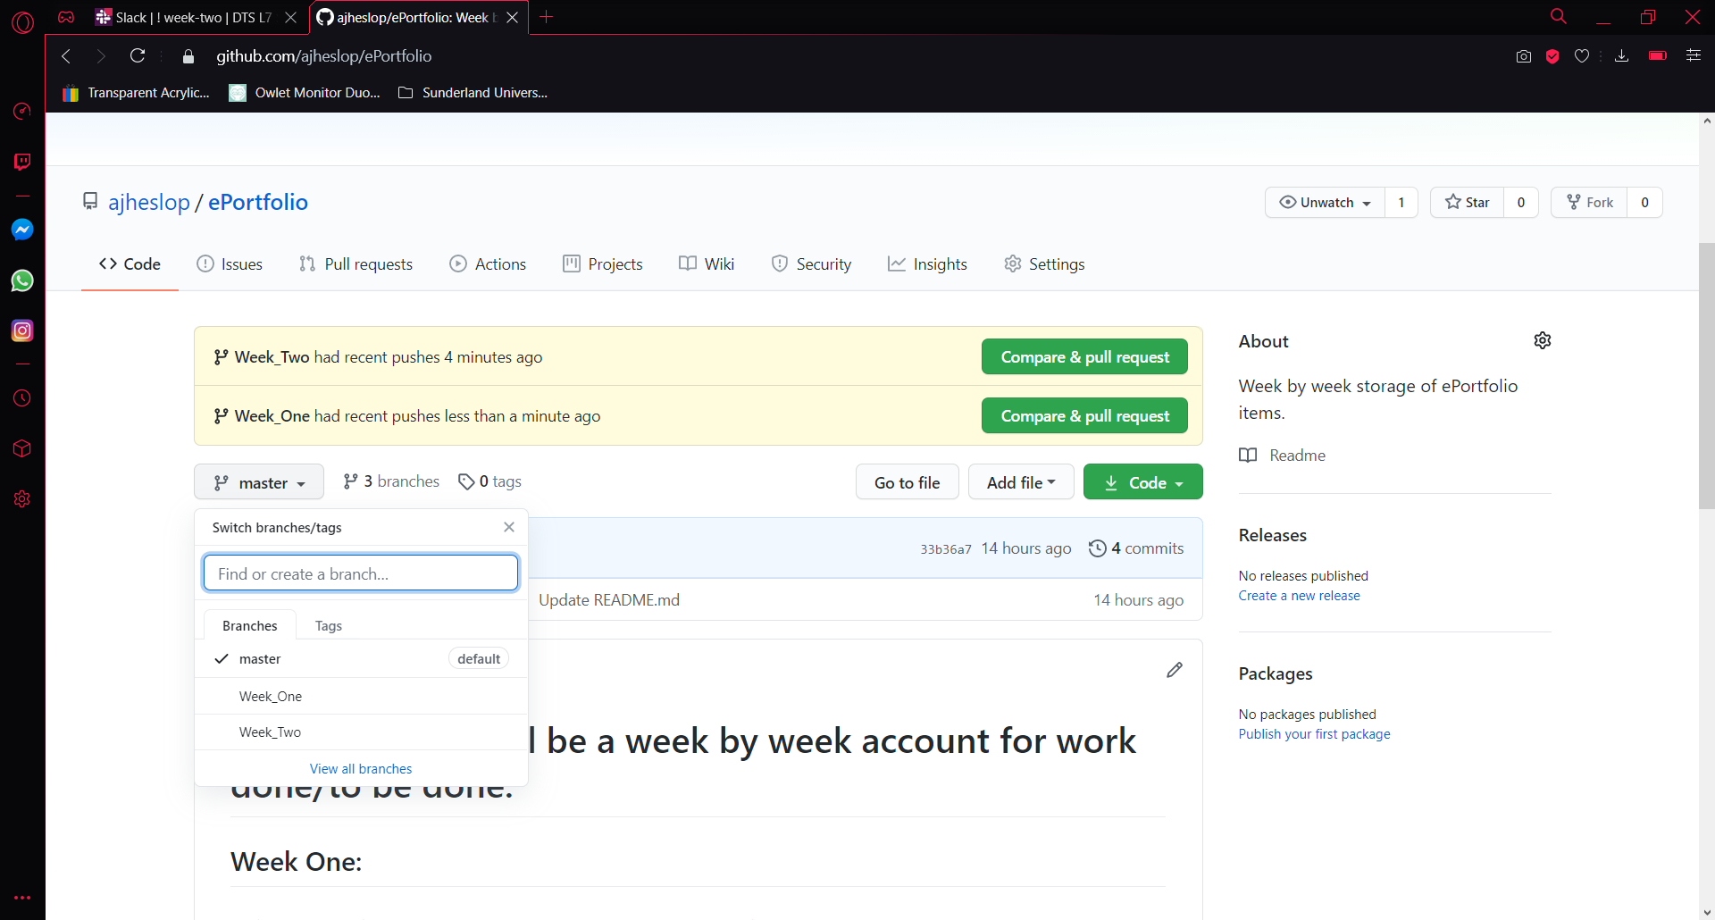

# Week One Pull Request

After comparing the pull request to identify any conflicts, I think submitted the pull request.

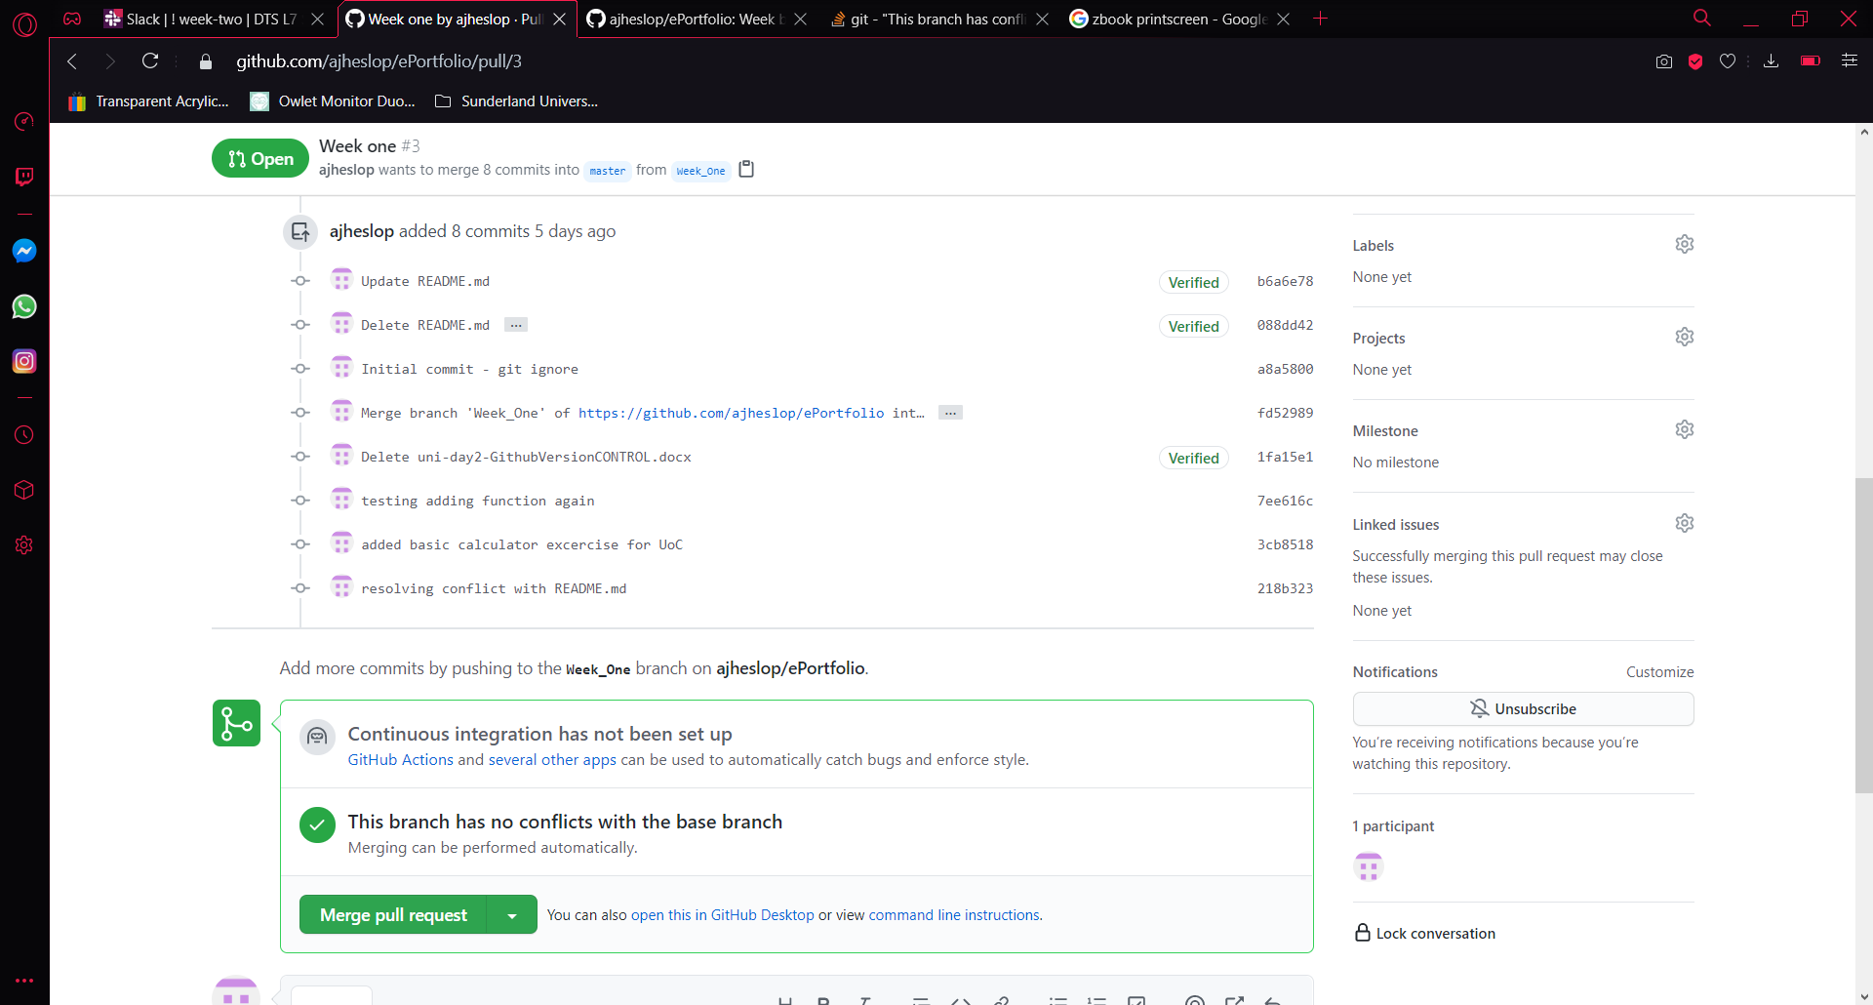

# Create a comment trail for the submission merge

I added a comment to confirm the reason I was creating the merge pull request, this is good overall in case another use must work on this branch they can see a history of appended comments.

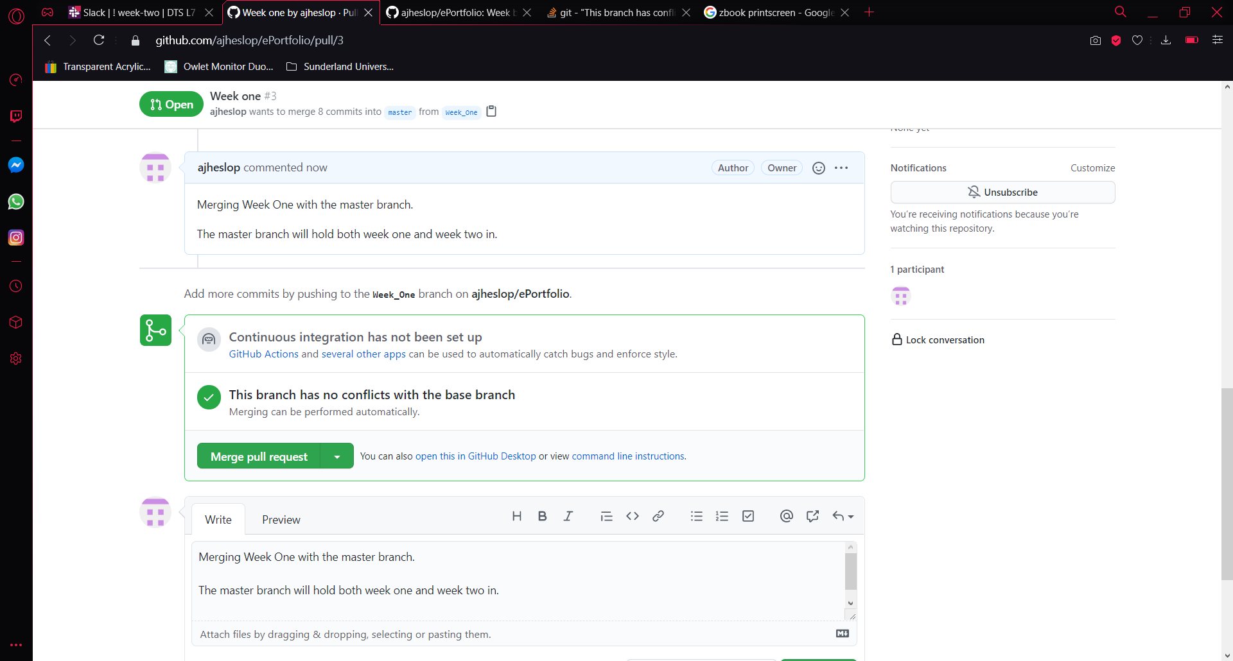

# Successful Merge

Once you’ve submitted your comment and merge request, you will be presented with a ‘Pull request successfully merged and closed’

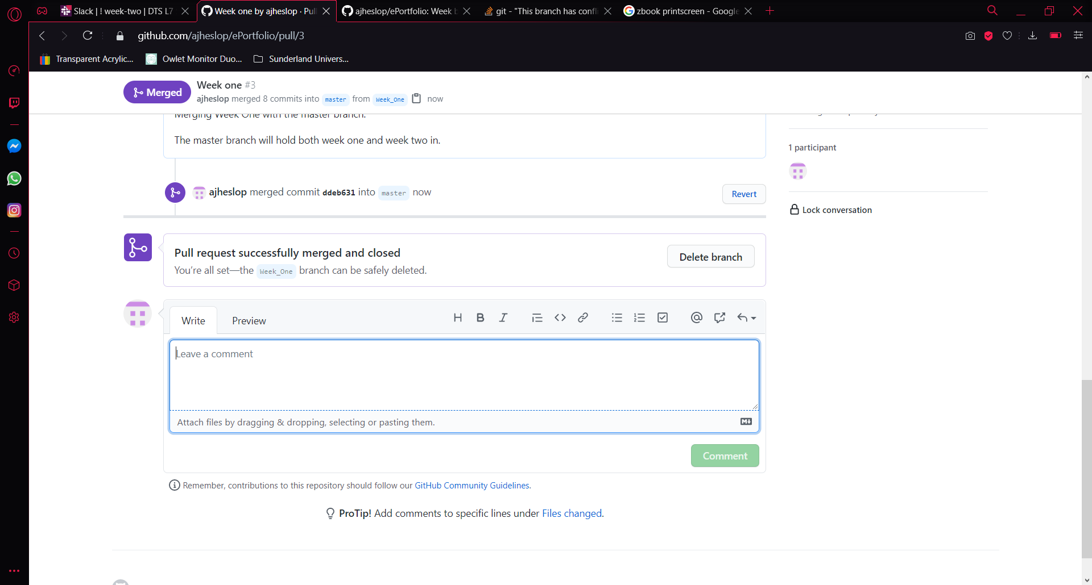

# Week Two Pull Request:

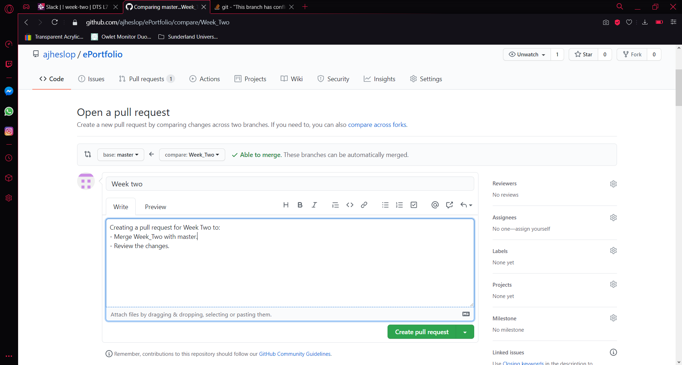

# Compare and pull request

Identifying if there are any conflicts or issues, and thus there are no – so I am now presented with an option to merge.

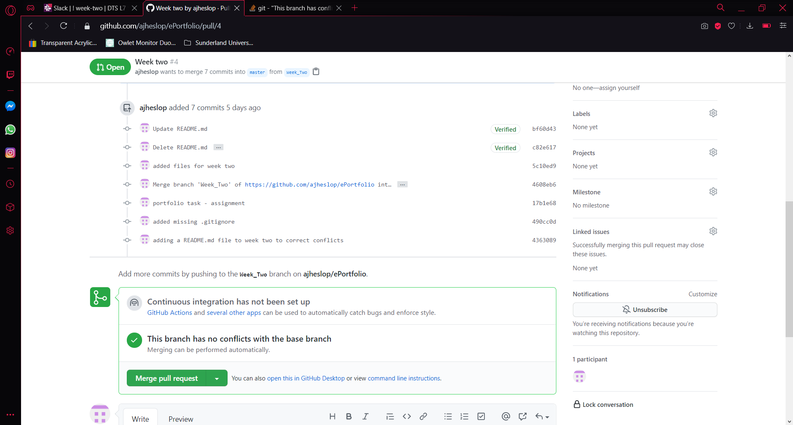

# Create a comment trail for the submission merge

I added a comment to confirm the reason I was creating the merge pull request, this is good overall in case another use must work on this branch they can see a history of appended comments.

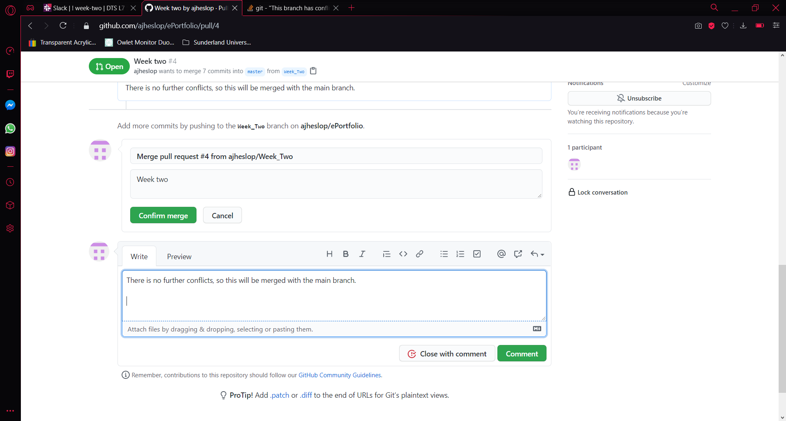

# Successful Merge

Once you’ve submitted your comment and merge request, you will be presented with a ‘Pull request successfully merged and closed’

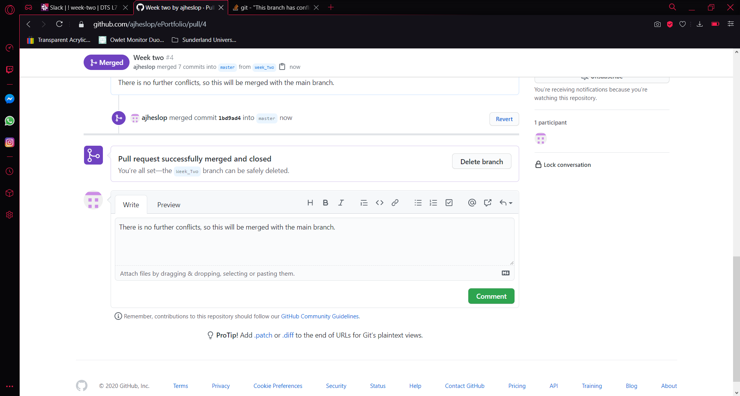

# Master view:

This is the result:

* Week One has now fully merged the most up to date files into the ‘master’ branch.
* Week Two has now fully merged the most up to date files into the ‘master’ branch.

